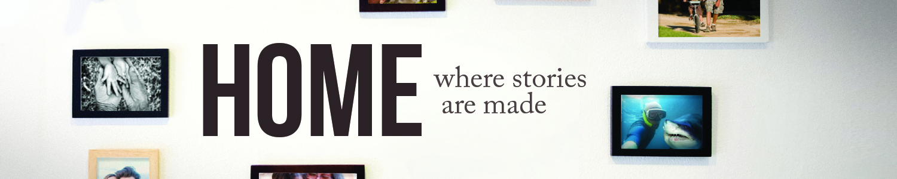

Home: Where Stories Are Made
There is Hope
January 8, 2017

This experience is designed to help guide you through praying together as a family. You can also commit to fast from something this week using that time and energy to focus deeper on your relationship with God and others. Small steps today could mean a big difference in the years to come!

Day 1: Home isn’t simply a place where we exist. God designed the family, in large part, to encourage one another in day-to-day life. Deut. 6:6&7 directs us to commit wholeheartedly to God’s commands; to talk about them with our children in the rhythm of everyday life. God gives us life’s direction through the Bible. Good intentions aren’t enough. We must take steps in the direction God instructs us to go. Prov. 27:12 says, “A prudent person foresees danger and takes precautions. The simpleton goes blindly on and suffers the consequences.” Gather the family and pray. If you’re empty nesters get together with your spouse. Single? Go to your favorite prayer spot. First, commit together that you will wholeheartedly follow God’s direction. This requires a day-to-day resolve. Second, ask God to help you see simple ways in your everyday life to do this. Remember, small changes today will make a big difference in the future. Find resources on how to spiritually lead your children at lscckc.org/parent-resources.

Day 2: Possibly the greatest challenge you will face committing wholeheartedly to God’s instruction is relational conflict. We were created to show God’s love. Everyday relationships with family, friends, neighbors, co-workers are where we have the greatest potential to live out God’s instructions. Read John 13:34,35. This “new commandment” Jesus gave seems simple. Loving others shows them Jesus. But what love is? Grab a sheet of paper, pen, and the family. Gather around the table and do this simple exercise. Read 1 Cor. 13:4-7. On one side of your paper list what love is as defined by 1 Cor. 13. On the other side list what love is not. Discuss how you can improve showing God’s love to others. Begin with your family, then classmates, neighbors, co-workers, etc. Write down and commit to one or two simple ways show love to these people.

Day 3: Communication is the cornerstone of relationships. It is the primary way in which we maintain intimacy. When communication is poor our relationships suffer. Healthy communication not only requires that we use our words effectively but that we also listen well. Read James 1:19. What does it mean to be “swift to hear” and “slow to speak”? Think about your most important relationships: family, work, neighbors. What will you do to improve your communication? Listen more? Block out distractions? Ask questions to show interest and clarify what you’ve heard? Yesterday, you listed ways to show love to important people in your life. What will you do to improve your communication with them? How can you be a better listener? Ask clarifying questions? Block out distractions? Add to yesterday’s list some specific ways you will improve your relationships through better communication. Offer David’s prayer in Psalm 141:3 to God in your own words.

Day 4: There are profound differences between men and women. Obviously, we differ physically in many ways. However, God never declares one gender more important or dominant over the other. In fact, God teaches gender differences compliment each other. Read Eph. 5:22-33. Marriage should be a reflection of Christ’s relationship to his church (see v. 32). John Piper writes, “A complementarian view concludes that biblical headship for the husband is the divine calling to take primary responsibility for Christlike servant-leadership, protection and provision in the home. Biblical submission for the wife is the divine calling to honor and affirm her husband’s leadership and help carry it through according to to her gifts. ‘A helper suitable for him,’ as Genesis 2:18 says.” Husbands and wives, does your relationship reflect this complementarian view? Do your children see sacrificial love and affirmation of God’s leadership in your lives? Single parent, your children need to see these same values in the way you relate to them. Single? How does this complementarian view change the way you relate to the opposite sex? Spend some time together in prayer. Talk with your family about how your relationships should reflect Jesus’ relationship with his church and each person’s role in this. Ask God for wisdom and humility to take on that role.

Day 5: You are a leader! Whether you want to be or not, you lead every day, even in your relationship with those in authority over you. How? Through influence. Read Malachi 4:5,6. Elijah was God’s prophet to the people of Israel. He used the truths of God and his God-given influence to turn people’s hearts back to a right living. Notice in verse 2, for those who “fear my name, the Sun of Righteousness will rise with healing in his wings.” Those who honor God will find health. Relationships will be restored. Life becomes meaningful and full of purpose. The way you lead (influence) your relationships will either turn hearts to God or away from him. Think about your family. Husbands, are you influencing your wives in a godly way? How about your children? Wives, are you honoring your husband in a way that encourages him to be your family’s spiritual leader? Singles, do you honor God at your job pointing others to Him? Children, honoring those in authority over you honors God. You will not always agree with them. But, honoring them will display love and influence them in a Christ-like way. Think about your relationships. How will you use your influence to honor others? Pray together with your family. Ask God to give you influence that will point other’s hearts toward Him.

Message Notes
Home: Where Stories Are Made
There is Hope
January 8, 2017

Proverbs 27:12: ‘A prudent person foresees danger and takes precautions. The simpleton goes blindly on and suffers the consequences.’ (NLT)

- When the prudent / wise see danger and trouble, they take ___________________.
- When the simple / naïve see danger and trouble, they ___________________.

All of life is ___________________. There is a direct correlation between what I ___________________ today and what I will ___________________ tomorrow. (idea from Principle of the Path)

The primary difference between the prudent and the simple is not in what they ________ but in how they ___________________.

If you want to ___________________ something you’ve never experienced before, you have to ____ things you’ve never done before.

Don’t pretend that all is ____________ when all is not ____________. Coming to a place of realizing that you need help doesn’t mean that you ____________ wisdom; but rather it’s the ___________________ of wisdom.

Hope is on the horizon. You may be living the reality of yesterday’s decisions, but with a tweak here and a shift there, paths can be altered, directions can be changed, pasts can be redeemed, and stories can have different endings. It’s not too late for hope to be renewed and courage restored.

Book: ‘The Principle of the Path’ by Andy Stanley. Available at the Next Steps Center for
$10.

Next Steps (Take 5 questions):
- Are there any discrepancies between what you desire in your heart and what you are doing with your life?
- What is one change (big or small) you could make to ensure that the story of your life turns out as you desire?
- In what area of life do you need a fresh dose of hope? Remind each other that with God’s Word and with God’s help that there is hope.

